 Lift the word easier

Quotation
To: | Date:
 | Client No:
 | Your Tel No:
 | Your Fax No:
 | Total page:
Dear Sir,

We thank you for your enquiry and pleased to offer on the basis of our general conditions of sale and delivery items as bellow:

- Standard Vacuum Lifter Model No. ESL140/30 1 set
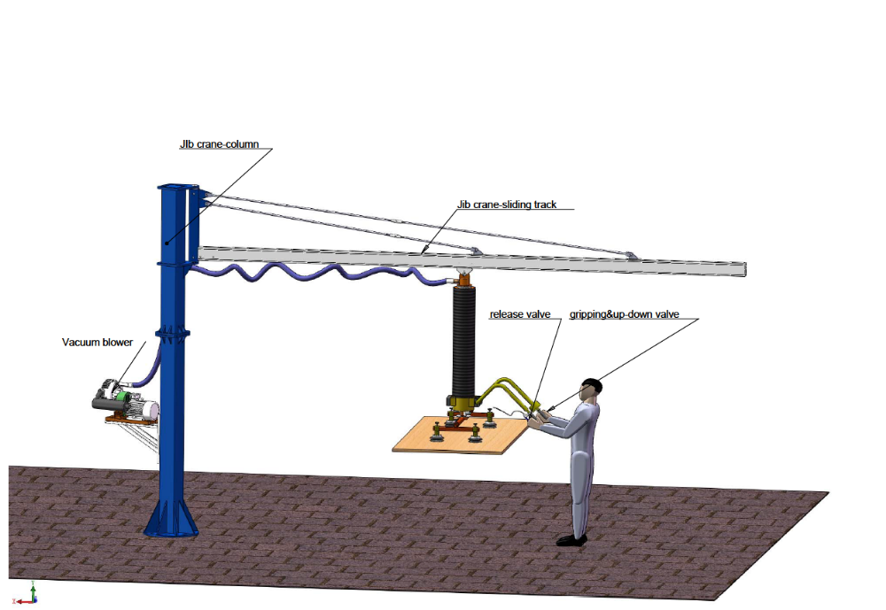
Main components:
- Vacuum blower: Siemens vacuum blower, model GS3.0, 380-440V,50HZ,3P 3.0KW, maximum vacuum flow 155cbm/h, maximum vacuum pressure -55kpa
- Lifting tube: diameter 140mm, tube length 2550mm, maximum lifting height 1700mm, maximum loading 40kg for semi-porous, 45kg for dense.
- 4 of round suction pads for carton box, the bellow pads diameter was 125mm ,the yoke length 350mm, width 300mm, mounted on the control housing by flange, suited for the box size of 600*600mm
- A ball bearing integrated upper rotation jointer with single way valve to prevent the goods falling down in case of power lost.
- Two-hands control unit with a “swing lever” handle for up and down, the brake handle for release
- A plastic vacuum filter mounted on the column to keep the air clean.
- A vacuum regulator mounted on the vacuum blower which protect the blower in case overheat, the preset vacuum pressure is -45kpa
- 10M vacuum feeding pipe of Diameter 52mm for vacuum feeding
- A electric control box mounted on the column for power switch
The lifter was designed for transportation or handling the materials at:
Max.carrying capacity:45kg for dense,40kg for semi-porous
Similar applications (for Carton box stacking):
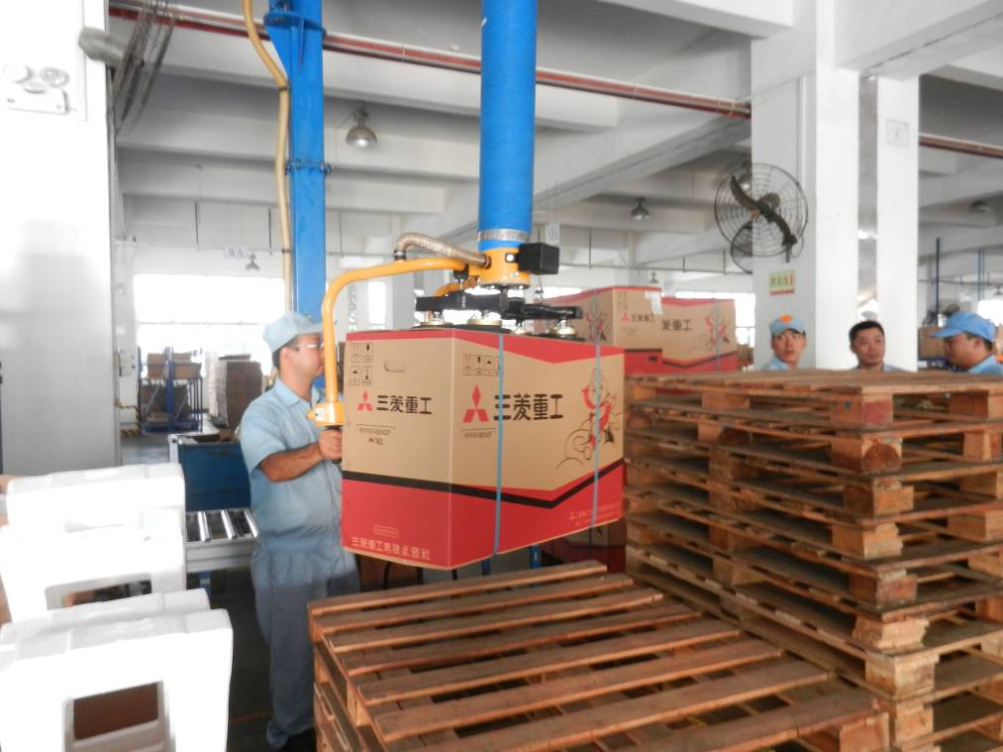
Options:
1. Silencer box for blower

Applications: Low headroom jib crane
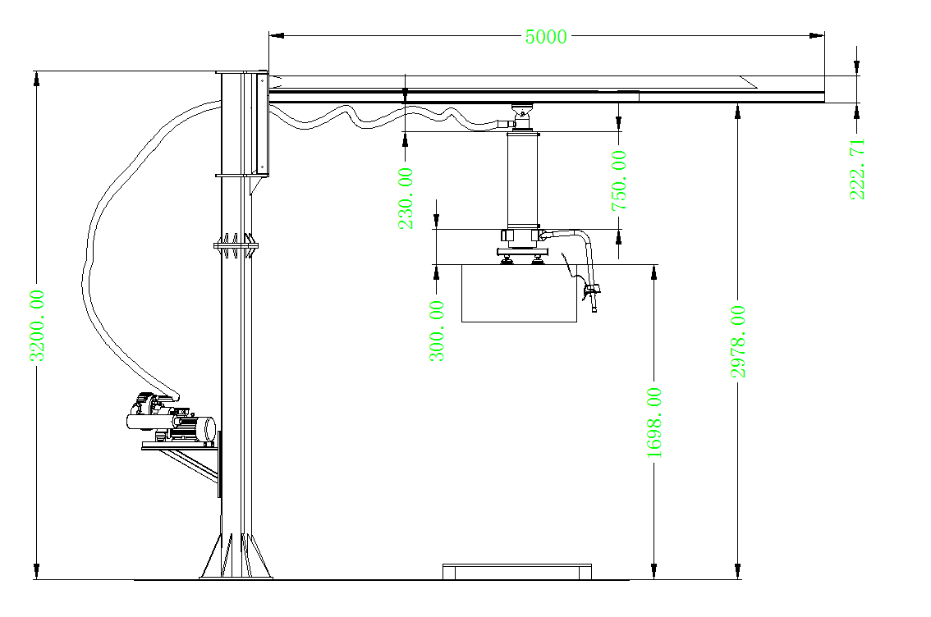

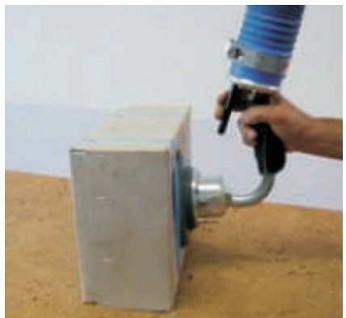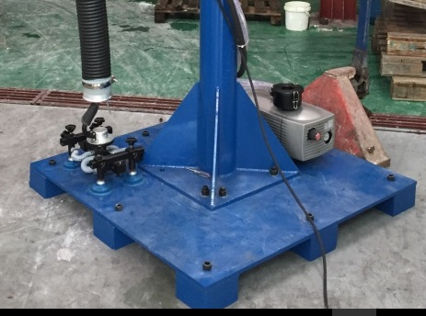

Price:
lifter 4300 USD
low headroom jib crane 3300 USD
Ex-work
Leading time: 15 working days after receipt of order
Terms of Payment: 50% down payment, balance before consignment

Recommended spare parts:
No | Spare parts | Spec/model/function | US $/unit | Replacement period
1 | Sucker lips | Dia.125mm，NBR | 19/unit | 18 months
2 | Transmission belt | PT220，Mitsubishi Japan | 53/unit | 3000 hours
3 | Vacuum transfer tube | Dia.52mm/Masterflex Germany | 23/m | 5000/hours
4 | Vacuum fan asbestos mat | Non-standard/Made in china | 6/unit | 10000/hours

Sucker lips
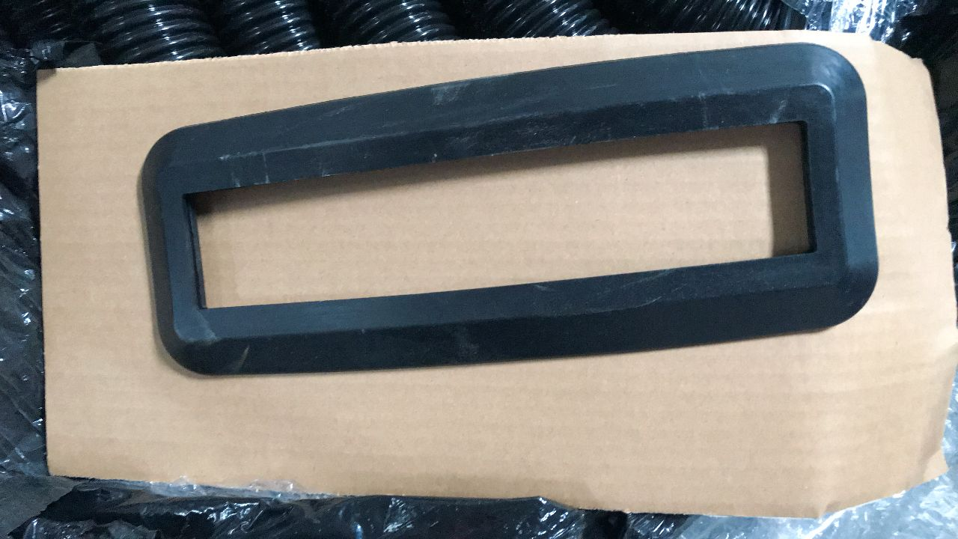
Transmission belt
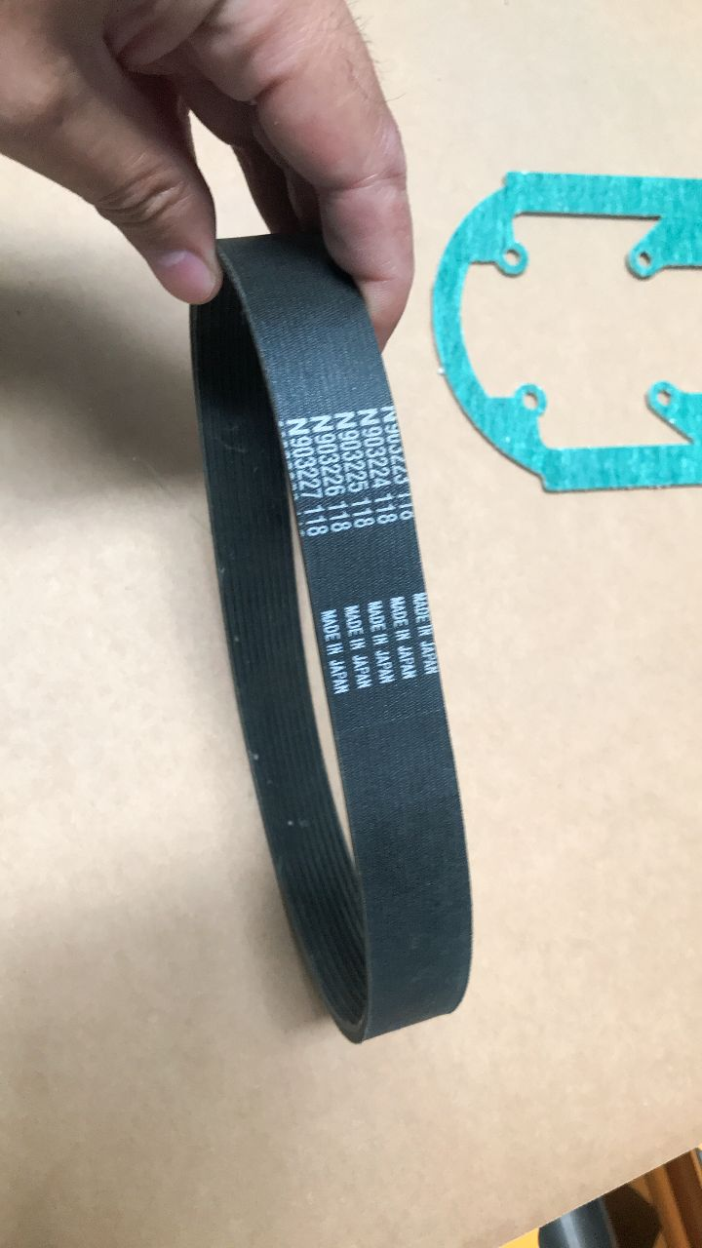
Vacuum transfer tube
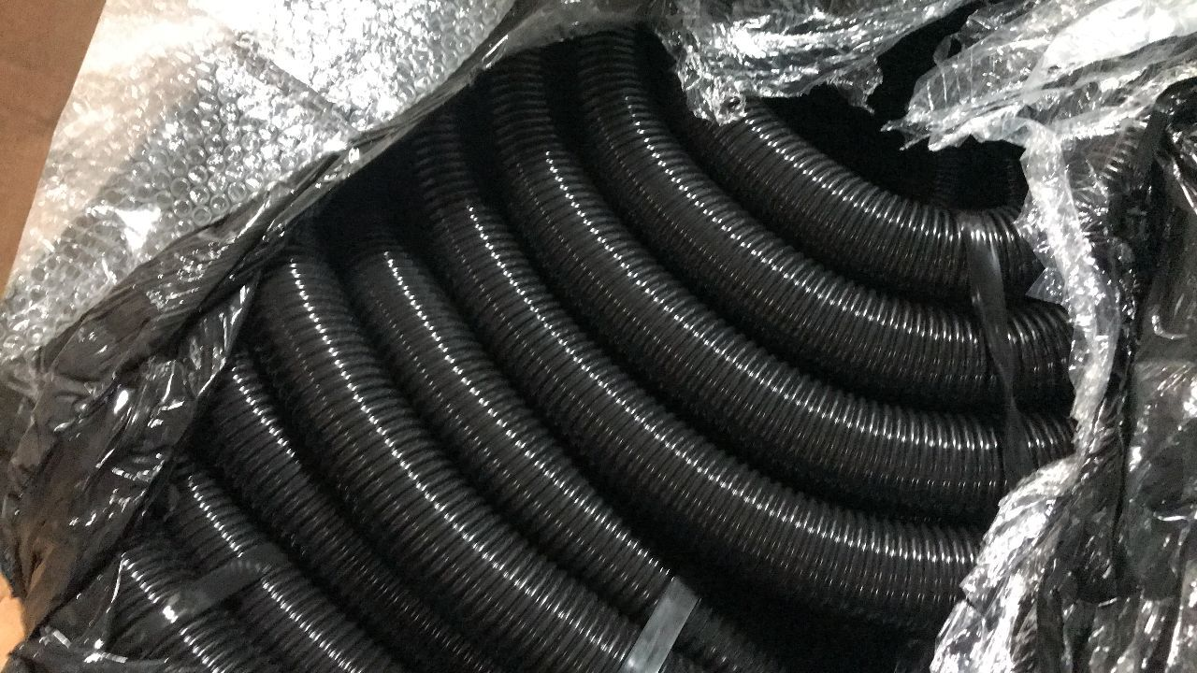
Vacuum fan asbestos mat


