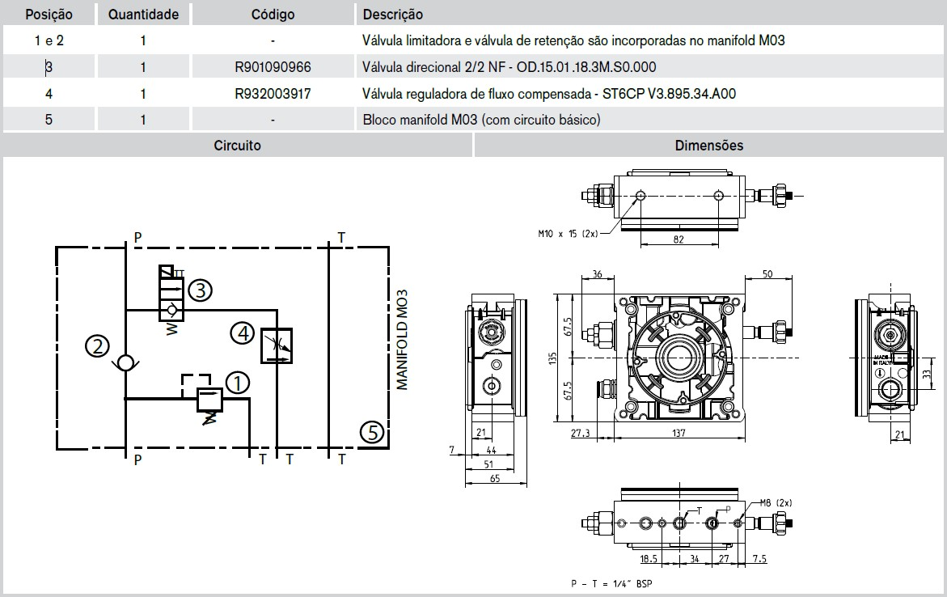

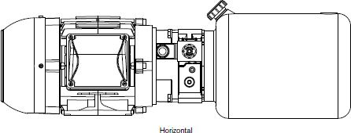
Horizontal mounting:

Maximum working pressure: 165Bar Flow rate: 1.66 liters per minute
Engine: 0.75HP Reservoir: 4 to 6 liters

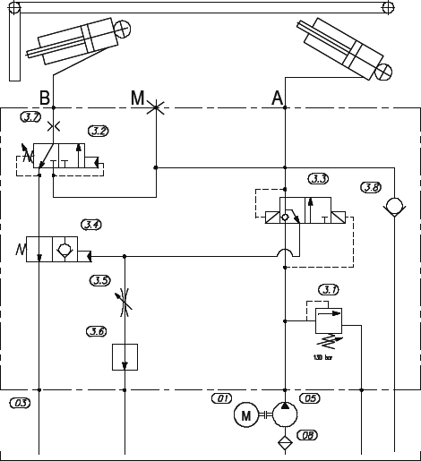

Horizontal mounting:
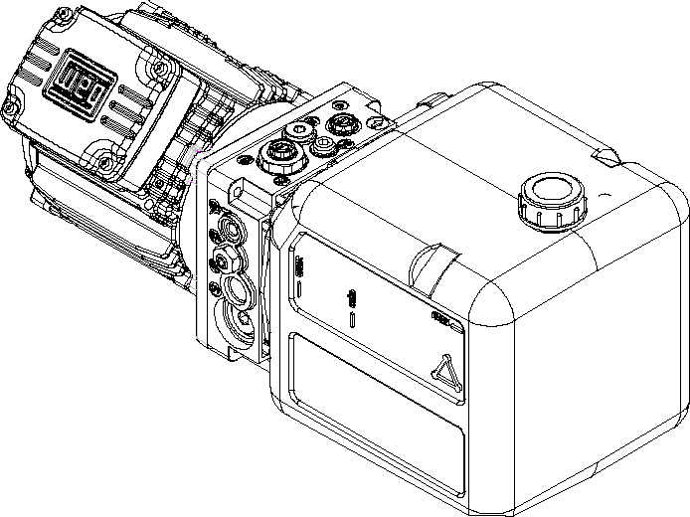

Maximum working pressure: 165Bar Flow rate: 1.66 liters per minute
Engine: 1.5HP Reservoir: 4 to 6 liters

