1.Lifting Davit

Seq. | BOQ Ref | Description | Location | Tag | QTY | Total Weight | Loading capacity 1.5 times heaviest piece | Length of arm | length of column | Tanks height (m)
IRBID location
1 | A.5.3.2.3.1 | Lifting Device | Stormwater Pumping Station | A-121-LiD-01 | 1 | 250 | 375 | 1.34 | 1.6 | 5.83
4 | A.5.2.3.2 | Lifting Device | Primary Scum Pumping Station | A-130-LiD-01 | 1 | 84 | 126 | 0.74 | 1.6 | 5.4
5 | A.5.6.1.2 | Lifting Device | FST Scum Pumping Stations | A-150-LiD-01 | 1 | 109 | 163.5 | 0.77 | 1.6 | 4.1
6 | A.5.10.5.2 | Lifting Device | Gravity Thickener Scum Pumping Station | A-202-LiD-01 | 1 | 78.3 | 117.45 | 0.95 | 1.6 | 3.6
7 | A.5.12.1.2 | Lifting Device | WAS Storage Tank (existing structure) | A-210-LiD-01/2 | 2 | 329 | 493.5 | 2.7 | 1.6 | 5.44
8 | A.5.15.2.1 | Lifting Device | Mechanical Thickener (GBT) Feed Tank | A-260-LiD-01 | 1 | 247 | 370.5 | 0.4 | 1.6 | 4.8
9 | A.5.25.3.1 | Lifting Device | Sludge Blending Tank | A-250-LiD-01 | 1 | 155 | 232.5 | 0.4 | 1.6 | 4.8
10 | A.5.13.3.1 | Lifting Device | Digested Sludge Storage Tank | A-220-LiD-01 | 1 | 170 | 255 | 0.4 | 1.6 | 4.8
11 | A.5.19.3.1 | Lifting Device | Return Liquor Pump Station | A-290-LiD-01 | 1 | 245 | 367.5 | 1.18 | 1.6 | 6.25
WADI ARAB Location
1 | B.8.36.1.4 | Lifting Device | Septage Reception Station | B-115-LiD-01 | 1 | 158 | 237 | 0.7 | 1.6 | 4.26
2 | B.9.2.2.2 | Lifting Device | Stormwater Tanks and Stormwater Pumping Station | B-120-LiD-01 | 1 | 250 | 375 | 1.34 | 1.6 | 7.25
3 | B.9.4.3.2 | Lifting Device | Primary Scum Pumping Station | B-132-LiD-01 | 1 | 98 | 147 | 0.95 | 1.6 | 3
4 | B.9.5.4.1 | Lifting Device | Activated Sludge Tanks | B-140-LiD-01…06 | 6 | 78 | 117 | 1.07 | 1.6 | 6.95
5 | B.9.39.1.3 | Lifting Device | RAS Pumping Stations |  | 6 | 211 | 316.5 |  |  | NA
6 | B.9.39.1.4 | Lifting Device | WAS Pumping Stations |  | 2 | 168 | 252 |  |  | NA
7 | B.9.21.3 | Lifting Device | Gravity Thickener Scum Pumping Station | B-212-LiD-01 | 1 | 98 | 147 | 1.07 | 1.6 | 3.6
8 | B.9.12.2.1 | Lifting Device | WAS Storage Tank | B-215-LiD-01/02 | 2 | 200 | 300 | 1.5 | 1.6 | 5.6
9 | B.9.14.4 | Lifting Device | Sludge Blending Tank | B-240-LiD-01 | 1 | 170 | 255 | 0.4 | 1.6 | 5.8
10 | B.9.13.3 | Lifting Device | Digested Sludge Storage Tank | B-241-LiD-01/02 | 2 | 175 | 262.5 | 0.4 | 1.6 | 5.6
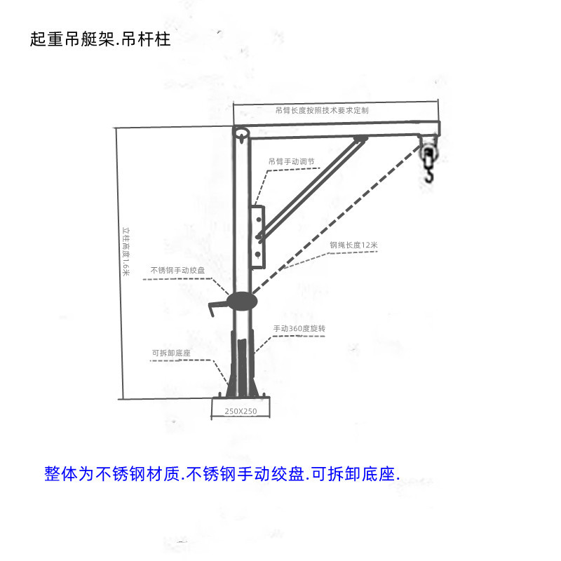
Lifting Davit： Length of arm will be manufactured according to your data above

2. Mobile Gantry crane, manually operated
1.span: 3meters
2.height of gantry crane unit: 2 meters
3.Lifting height of chain: 9 meters (as the gantry crane will be located in second floor to lift pumps
located in ground floor)
